Sunrise SCM_SAP_SAPMaterialMasterBOMUpdate

TIBCO Detailed Design Specification

Author: Deloitte
Creation Date: 10th August, 2005
Last Updated:

Revision History
Date | Description | Author/Review | Version
08/10/05 | Initial draft | Praveen Nuthulapati | 1.0
12/01/05 | Updated for SFA | Karun Viswanath | 1.1

Related Documents
Date | Version | Document Name | Description
 |  | Product Updates To SFA.doc | Functional Specs

Table of Contents
0.0 Introduction 4
0.1 Purpose 4
0.2 Audience 4
1.0 SCM_SAP_Service Project Architecture 5
2.0 SAPMaterialMasterBOMUpdate 6
2.1 Logical Design 6
2.2 Physical Architecture (Topology) 7
2.3 Event Flow 8
2.4 Activity Diagram 9
2.5 Configuration Details 11
SAP Adapter Configuration Details 11
2.6 Use Cases 12
2.6.1 SAPMaterialMasterBOMUpdate 12
2.7 Key Performance Indicators / Metrics 13
2.8 Error Handling 14
2.8.1 SAPPurchaseOrderUpdate 14
2.9 Mapping Detail 15
2.10 Additional Data Processing 16
2.11 Business Works Component Inventory 17
2.12 Assumptions 18
2.13 Issues 19
2.14 Sign-off 20

0.0 Introduction

0.1 Purpose

The scope of this document is to provide the technical design for the services in the SCM SAP Service TIBCO project. This TIBCO project contains all the services that are a part of the SCM functional space and are provided by SAP system. This project contains SCM Sunrise Business Services (SBS), provided by SAP system. Each interface in FRICE is represented as a SBS.

0.2 Audience
This document contains information that can benefit TIBCO developers and architects. The reader should have an understanding of EAI (Enterprise Application Integration) technology and the tools used by the HMCo Integration Center for business integration (e.g TIBCO)

SCM_SAP_Service Project Architecture

The figure below reflects the TIBCO Business Works project architecture to support the interfaces in the Sunrise project. SAP through TIBCO needs to interact with backend legacy systems support various business processes like Material Movement, Shipping etc. within the SCM space. So SAP may expose a service via TIBCO or serve as a Consumer for users to support business process interactions with backend legacy systems, via TIBCO.

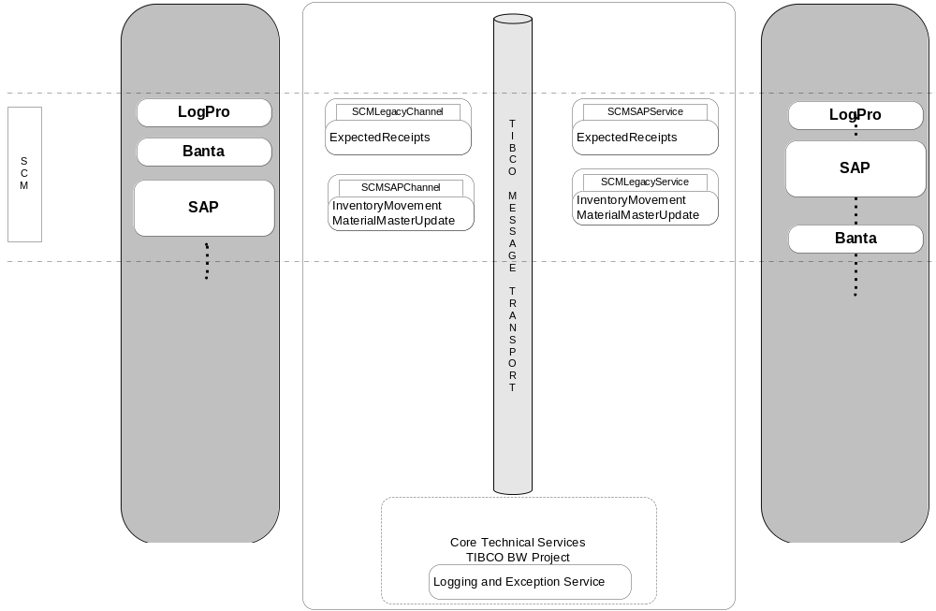
Figure 1.0 Project Architecture Diagram

Each interface is represented as a Sunrise Business Service (SBS) within the SCM space for SAP - Legacy interactions. Below is a list of services/interfaces that are provided by SAP system and exposed in this project within the SCM functional area.

FRICE. ID | Interface Description | Process Name
683 | This interface sends updated Material information from SAP to SFA | SAPMaterialMasterBOMUpdate

SAPMaterialMasterBOMUpdate
This service supports the SAPMaterialMasterBOMUpdate process. It receives material master details from the SAP system. The main TIBCO folder “SAPMaterialMasterBOMUpdate” will contain main processes. The process name is SAPMaterialMasterBOMUpdate.
The process contains the logic to receive the material master information from SAP and publishes the message as Ae format into the JMS per the mapping rules in the mapping spreadsheet.

Logical Design
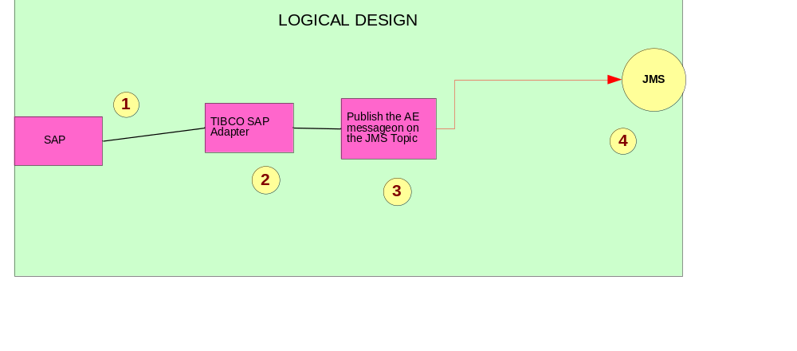

Figure 1: Logical Diagram for SAPMaterialMasterBOMUpdate

The logical design represents the SAPMaterialMasterBOMUpdate process.

Physical Architecture (Topology)

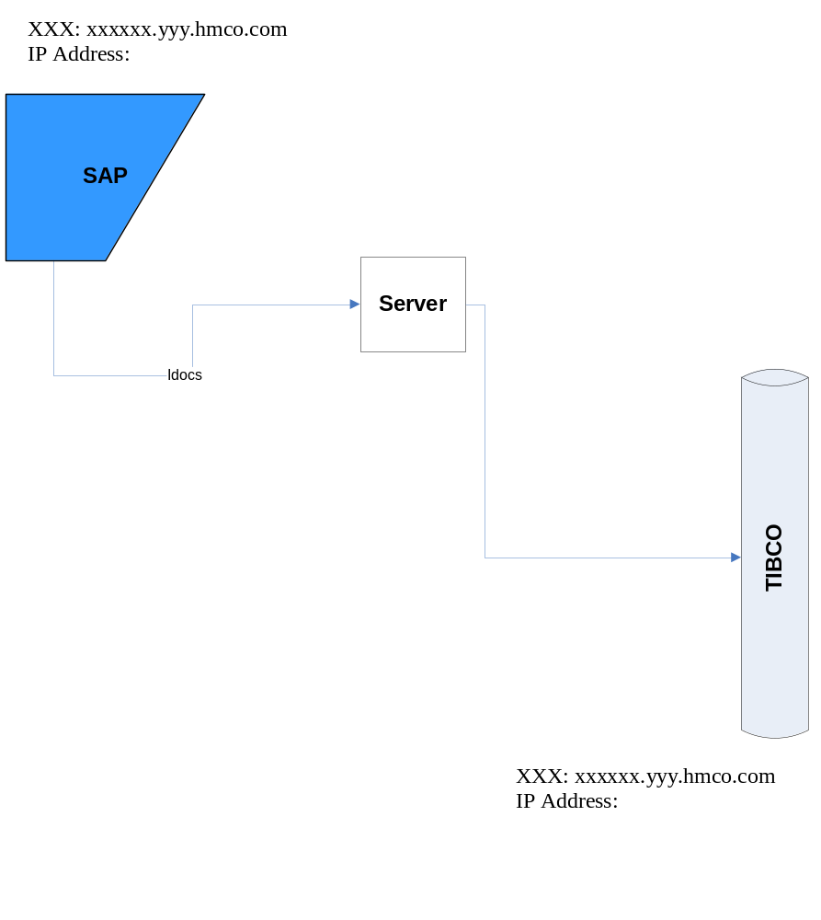

The physical architecture represents the SAP touch points with TIBCO for the SAPMaterialMasterBOMUpdate Service.

Event Flow
Following sequence diagram shows the message flow for SAPMaterialMasterBOMUpdate from SAP to Legacy through TIBCO.
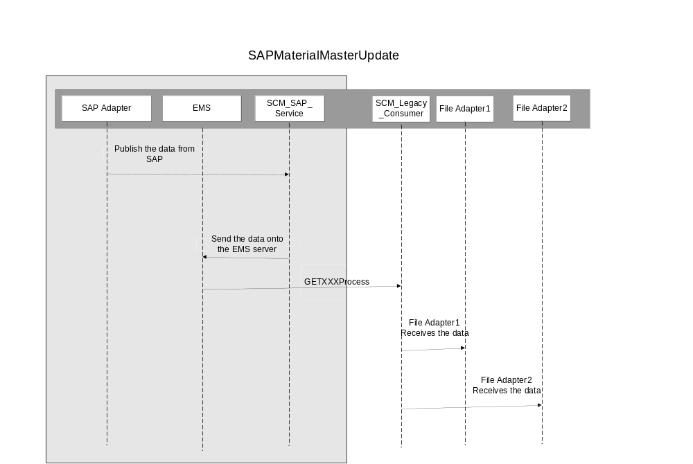

Activity Diagram
The figure below represents the process steps for SAPMaterialMasterBOMUpdate process with in SCM_SAP_service interface.
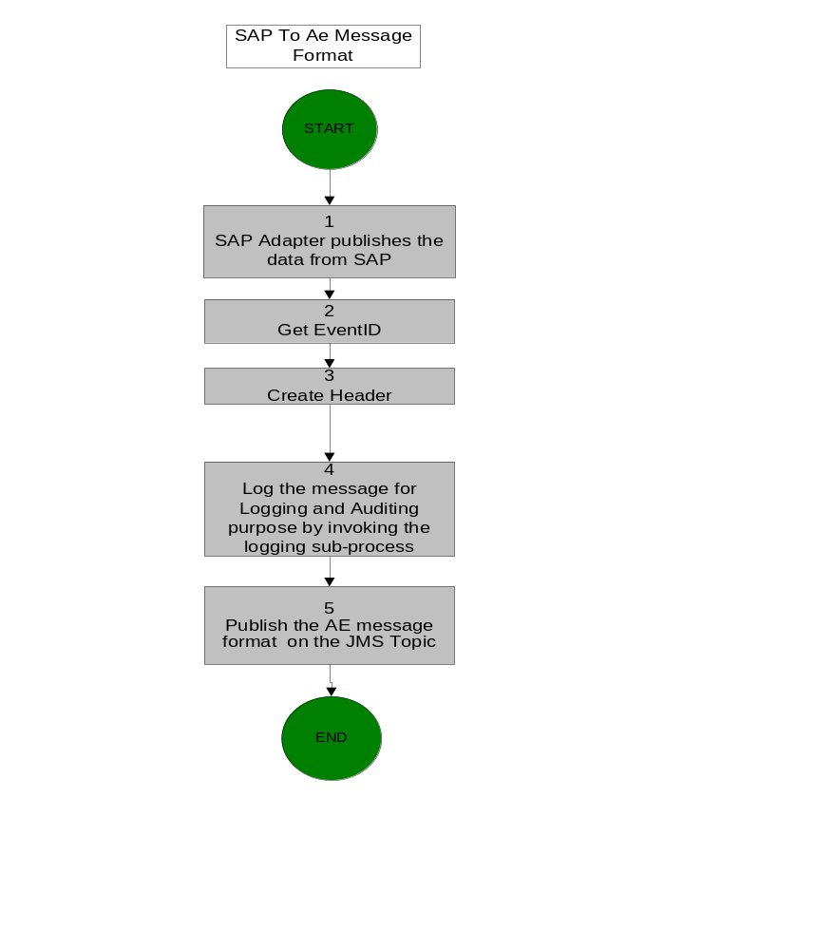

Figure4: SAPMaterialMasterBOMUpdate Activity Diagram

Activity Detail

Activity. No. | Activity Detail
1 | SAP Adapter – GetSAPMaterialMasterBOMUpdate. This activity gets the data from the SAP .
2 | Get the event Id
3 | Create the header information
4 | Log the message for logging and auditing purpose
5 | Publish the TIBCO message on the JMS Topic

Configuration Details

SAP Adapter Configuration Details
Property | Value
Application Server | My eRooms > Sunrise Technical > Technical > Documentation > TIBCO > Design > Adapters > SAP Adapter -SAP TIBCO Interface Configuration.xls
System Number | My eRooms > Sunrise Technical > Technical > Documentation > TIBCO > Design > Adapters > SAP Adapter -SAP TIBCO Interface Configuration.xls
Client | My eRooms > Sunrise Technical > Technical > Documentation > TIBCO > Design > Adapters > SAP Adapter -SAP TIBCO Interface Configuration.xls
Username | My eRooms > Sunrise Technical > Technical > Documentation > TIBCO > Design > Adapters > SAP Adapter -SAP TIBCO Interface Configuration.xls
Password | My eRooms > Sunrise Technical > Technical > Documentation > TIBCO > Design > Adapters > SAP Adapter -SAP TIBCO Interface Configuration.xls
Name | SCM_OUT_ADR3
Transport Type | JMS
Wire Format | XML
Delivery Mode | Persistent
Connection Factory Type | Queue
Service Name | Pub_MaterialMasterUpdate

Schema
Property | Value
Select Idoc | MATMAS01
EDI_DC fields | Refer to document “Section_2_Material_Master_Product_Updates_to_SFA_683_TIBCO_Map.xls  ”

JMS Specifications
Property | Value
Transport type | JMS Topic
Delivery mode | Persistent
Destination Queue / Topic Name | My eRooms > Sunrise Technical > Technical > Documentation > TIBCO > Design > EMS Queue Configuration “common_TIBCO_IC_DEV.script”
SSL | No

Use Cases

Use Case Id | Use Case Description
SAP_01 | When ever there is change or addition of material master record

Key Performance Indicators / Metrics

NA

Logging and Error Handling
All TIBCO projects log messages and errors to a central core technical services project. Every event that crosses the TIBCO boundaries is logged. Exceptions are also logged. Below is a list of exceptions that will be handled by this process

Please see the HMCo Core Technical Services document for further details for the logging and exception service.

Activity | Exception Scenario | Exception Type | Comments
Adapter | SAP Adapter down | System | SAP will send the data to TIBCO once the SAP adapter is up and running
Adapter | SAP down | System | SAP will send the data once the SAP is up and running.

Sensitivity Requirement for Logging - No
Refer to the Sunrise Error Handling Strategy document

My eRooms > Sunrise Technical > Technical > Documentation > TIBCO > Design > Sunrise TIBCO Standards > Sunrise Error Handling Strategy.doc

Functional_ID Implementation

Functional_ID implementation is an alternative tracking mechanism developed to track the information flow between SAP and Legacy systems.
In past, the only way to track the information flow was to look for SAP Idoc numbers in TIBCO database. In current implementation a new table called EAI_LOG_HEADERS has been created.

The table structure is as follows -

EAI_LOG_HEADERS
EVENT_ID | String | Primary Key
H_NAME | string
H_VALUE | String

For all Idocs the corresponding function Id will be fetched in TIBCO interfaces and the information will be logged in above table.
For ex A material master idoc (BOMMAT03-ZBOMMAT03-4x) will have the material number in MATNR field. In tibco interface, that field will be fetched and will be logged in above table.
The row inserted in above table will look like this –

InterfaceName | EVENT_ID | H_NAME | H_VALUE
SAPMaterialMasterBOMUpdate | 2011-02-01T15:27:55.828+05:3082001 | MaterialID | 000000000000900004

Where the first column will be the event ID which will correspond to the Event ID field in EAI_LOG table .

Thus through construction of proper SQL queries, status of an Idoc generated on a particular date for a specific material number can be determined.

A GUI will be built on this table which will enable the user to search the information with relevant functional Ids in future.

All TIBCO projects log FunctionalID to a central core technical services project. Every event that crosses the TIBCO boundaries is logged. Below is a list of Name and Value that will be handled by this process.

Mapping Detail
Refer to the Mapping Excel sheets “Section_2_Material_Master_Product_Updates_to_SFA_683_TIBCO_Map.xls
”

Cross Reference Details
NA

Business Works Component Inventory

The components used or updated as part of this specification will be selected and configured based on the detailed information captured in the activity diagram and activity diagram description. The same is true for the processes that will be generated or called as part of the specification.

In order to follow best practices for single-source data, the information will not be re-captured in this document. Rather, the information will be available through Business Designer via XML Canon when needed. XML Canon is the design-time repository for all TIBCO BW components, processes and projects. XML Canon also has capabilities to run component inventory reports and the ability to setup custom reporting as necessary.

The XML Canon repository that corresponds to this document is:
http://neduapp001.hmco.com:8088/Sunrise/SCM/SCM_SAP_Service/

Assumptions

NA

Issues

NA

Sign-off

Name | Role | Date | Signature
 | Spec Writer
 | Process Owner
 | Etc…

